Wizards

Exercise 1: Investigation

Answer the following questions about the FNOL wizard PCF file.

1. What is the name of the first wizard step? What is the name of the screen it points to?

1. How many wizard step sets are there in the wizard?
2. In the GeneralPropertyWizardStepSet, how many of the steps have at least one Next condition?
3. Which property of the wizard is used to specify the message to display when a user attempts to cancel out of the wizard. (This was not explicitly discussed in the presentation, but you should be able to determine this by reviewing the wizard PCF file.)
4. What must be true in order for the Services wizard step to be available?

Exercise 2: Configuration

Configure ClaimCenter to meet the following customer requirement from Acme Insurance.

Requirement: Easy Access to Vehicle Information

During claim intake for **Personal Auto** claims, Acme Insurance customer service representatives often have to access the list of involved vehicles several times throughout the intake call. They want service reps to have an easier time identifying where to access this information in the wizard. Therefore, they are requesting that the list of involved vehicles, which is currently on the **Basic Info** step, be moved to its own **Vehicle Info** step.

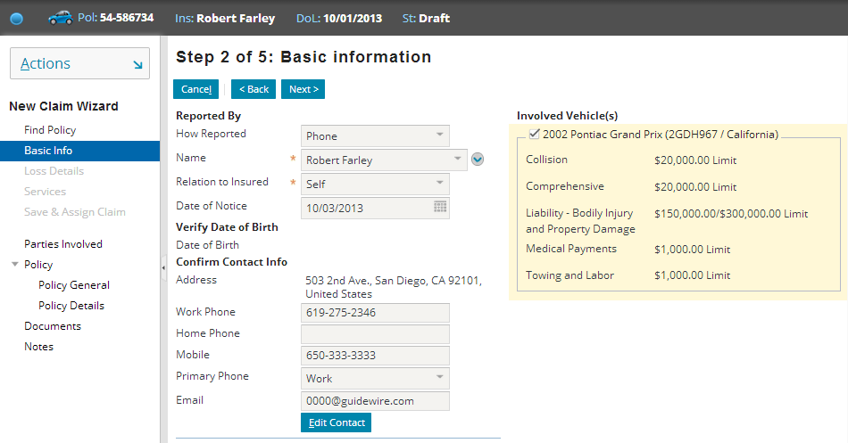

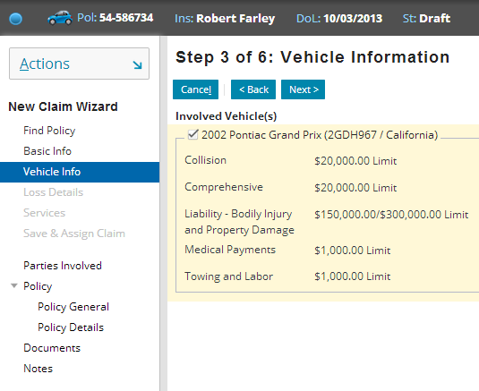

Before proceeding, read all the steps below to understand the overall process. At a high level, you are going to start with the existing screen, and use two copies of it to represent 1) the new basic info screen for Personal Auto claims, and 2) the new vehicle info screen for Personal Auto claims. The original screen will still be used for non-Personal Auto claims.

1. Create a new Basic Info screen for Personal Auto claims.  
   Recommended approach: Duplicate (copy) the existing Basic Info screen that contains the Vehicle info and name it so that it is called only for loss types of "Auto". (HINT: To copy a PCF, select the PCF in the Project view, right-click and choose “Copy”). Paste the PCF into the same location but with a name reflecting the appropriate mode. In the new “Auto” Basic Info screen, set the entire right column containing the vehicle info to be visible for policy types other than Personal Auto. (Hint: Select the column.)
2. Create a new screen to contain the Vehicle Info.   
   Recommended approach: Duplicate (copy) the existing Basic Info screen that contains the Vehicle info and name it with a new filename of "FNOLWizard_VehicleInfoScreen.default". In the new VehicleInfo screen, disable the entire left column.
3. Create a new wizard step immediately after the Basic Info step which is labeled "Vehicle Information" on the user interface.   
   Recommended approach: Duplicate the Basic Info Wizard Step and modify it to reference your new Vehicle Info screen.
4. Create new display keys to contain for both the title and labels associated with your new Wizard Step.  
   Recommended approach: Locate the display keys used for the Basic Info Wizard Step and then use the Display Keys Editor to create similar keys for the Vehicle step. In the Wizard Step, modify the label and title properties that refer to the new display keys.
5. Modify the wizard so that the Vehicle Information step appears only for Personal Auto claims.  
   Recommended approach: Create a visible attribute for the step you want to display conditionally.

**Test Cases**

When you have completed your configuration, reload your changes to PCFs (ALT+SHIFT+L) and run the following test cases:

1. Log on as Andy Applegate (aapplegate). Start a new auto claim using any personal auto policy (such as policy 54-123456). Verify that the **Basic Information** step contains no list of vehicles but there is a separate **Vehicle Information** step. You do not need to complete the claim.

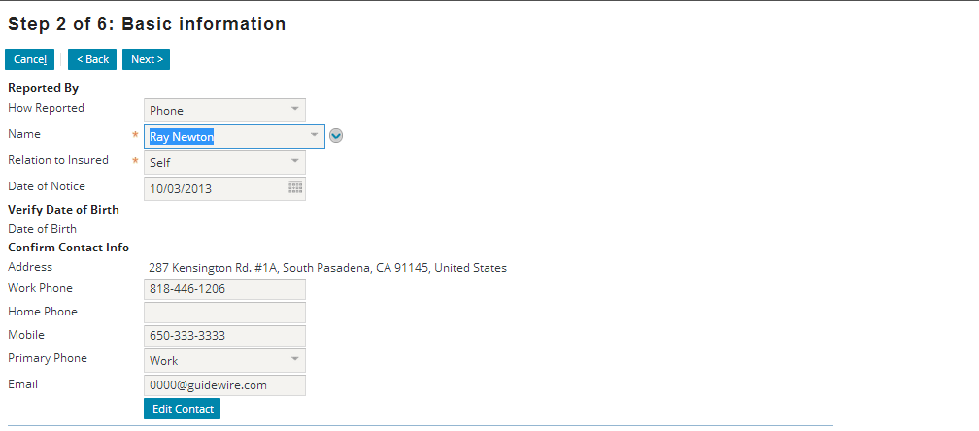

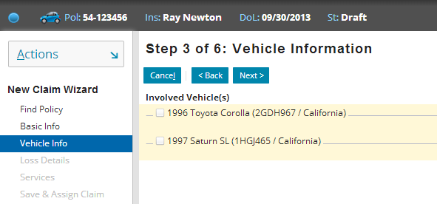

1. Start a new Homeowner's claim using any Homeowner's policy (such as policy 53-235675). Verify that the Vehicle Information step does not appear in the wizard menu links and that the property info is still displayed in the right column. You do not need to complete the claim.

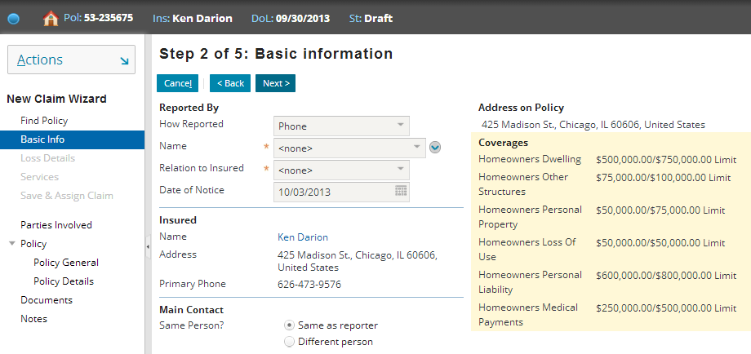

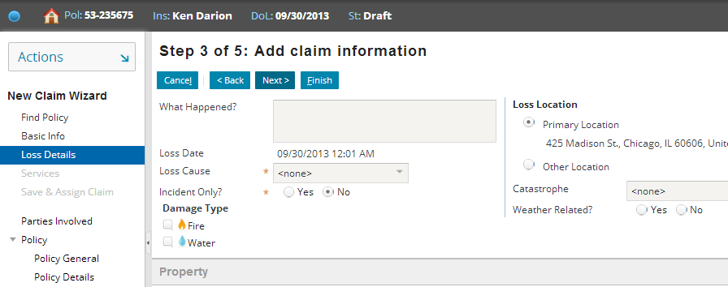

1. Start a new Commercial Auto claim using any Commercial Auto policy (such as policy 64-318764 (Long Road Trucking)). Verify that the Vehicle Information step does not appear in the wizard menu links and that the Involved vehicles is still displayed in the right column. You do not need to complete the claim.

